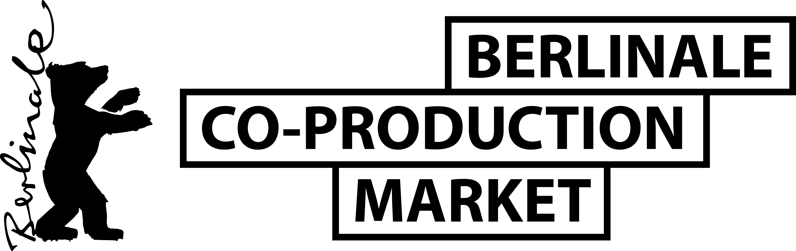
VISITORS PROGRAMME 2025
REGISTRATION FORM*

Information for publication in the Visitors Brochure
Company
Country
First Name
Last Name
Phone
Mobile
E-mail
Website
Short Company Profile (max. 700 characters incl. spaces)
3 recent film credits of the company - Use the following format:
TITLE by director, year, country/ies of origin, festival premiere, awards
(and please specify: feature, doc, short, animation, VR, drama series)

Representative’s Photo
Please attach as jpeg or png file

Please return the completed form as a Word document together with a headshot to your contact at the institution that is inviting you to participate in the Visitors Programme.

PLEASE NOTE

- By registering for the Visitors Programme, you agree that your information in this form will be published in the Berlinale Co-Production Market’s Visitors Brochure.

- Most sessions are planned to be accessible on-site. A part of the programme, such as the Visitors Meet & Match, might be held entirely online, to facilitate for all Visitors to jointly attend together and meet each other.

- As a Visitor, you will not have the opportunity to book meetings with our projects and/or present your project in public and you will not be part of our official Participants Directory. This is reserved for those participants, who have international co-production experience.

